DYNAMIC ROUTING RIP (V2)

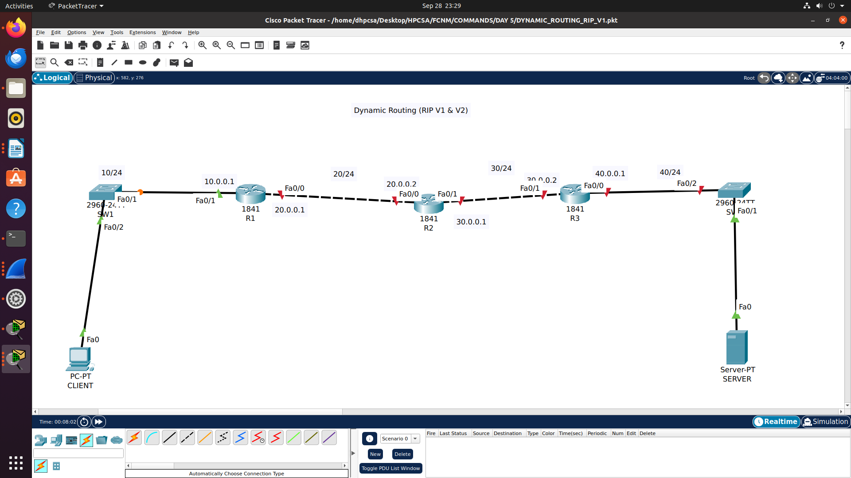

R1(config)#router rip
R1(config-router)#version 2
R1(config-router)#no auto-summary
R1(config-router)#network 10.0.0.0
R1(config-router)#network 20.0.0.0

R2(config)#router rip
R2(config-router)#version 2
R2(config-router)#no auto-summary
R2(config-router)#network 20.0.0.0
R2(config-router)#network 30.0.0.0

R3(config)#router rip
R3(config-router)#version 2
R3(config-router)#no auto-summary
R3(config-router)#network 30.0.0.0
R3(config-router)#network 40.0.0.0

R1#sh ip route
Codes: C - connected, S - static, I - IGRP, R - RIP, M - mobile, B - BGP
D - EIGRP, EX - EIGRP external, O - OSPF, IA - OSPF inter area
N1 - OSPF NSSA external type 1, N2 - OSPF NSSA external type 2
E1 - OSPF external type 1, E2 - OSPF external type 2, E - EGP
i - IS-IS, L1 - IS-IS level-1, L2 - IS-IS level-2, ia - IS-IS inter area
* - candidate default, U - per-user static route, o - ODR
P - periodic downloaded static route

Gateway of last resort is not set

10.0.0.0/24 is subnetted, 1 subnets
C 10.0.0.0 is directly connected, FastEthernet0/1
20.0.0.0/24 is subnetted, 1 subnets
C 20.0.0.0 is directly connected, FastEthernet0/0
30.0.0.0/24 is subnetted, 1 subnets
R 30.0.0.0 [120/1] via 20.0.0.2, 00:00:09, FastEthernet0/0
40.0.0.0/24 is subnetted, 1 subnets
R 40.0.0.0 [120/2] via 20.0.0.2, 00:00:09, FastEthernet0/0

R1#debug ip rip
RIP protocol debugging is on
R1#RIP: received v2 update from 20.0.0.2 on FastEthernet0/0
30.0.0.0/24 via 0.0.0.0 in 1 hops
40.0.0.0/24 via 0.0.0.0 in 2 hops
RIP: sending v2 update to 224.0.0.9 via FastEthernet0/0 (20.0.0.1)
RIP: build update entries
10.0.0.0/24 via 0.0.0.0, metric 1, tag 0
RIP: sending v2 update to 224.0.0.9 via FastEthernet0/1 (10.0.0.1)
RIP: build update entries
20.0.0.0/24 via 0.0.0.0, metric 1, tag 0
30.0.0.0/24 via 0.0.0.0, metric 2, tag 0
40.0.0.0/24 via 0.0.0.0, metric 3, tag 0
RIP: received v2 update from 20.0.0.2 on FastEthernet0/0
30.0.0.0/24 via 0.0.0.0 in 1 hops
40.0.0.0/24 via 0.0.0.0 in 2 hops

R1#no debug ip rip
RIP protocol debugging is off

